**DHCP Server**

**Add** HWIC-1GE-SFP ports:

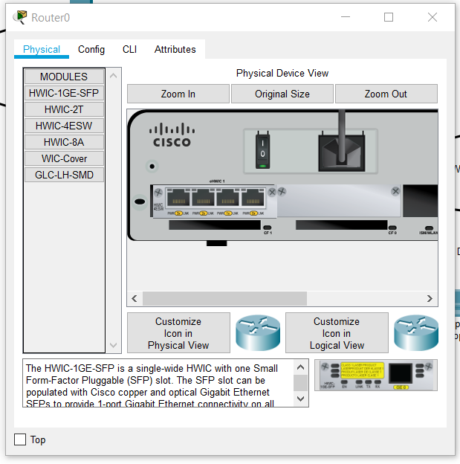

**Then Config DHCP server:**

